GENERATION OF TRIANGULAR WAVE USING PROTEUS

Procedure:
1.Select signal generator.
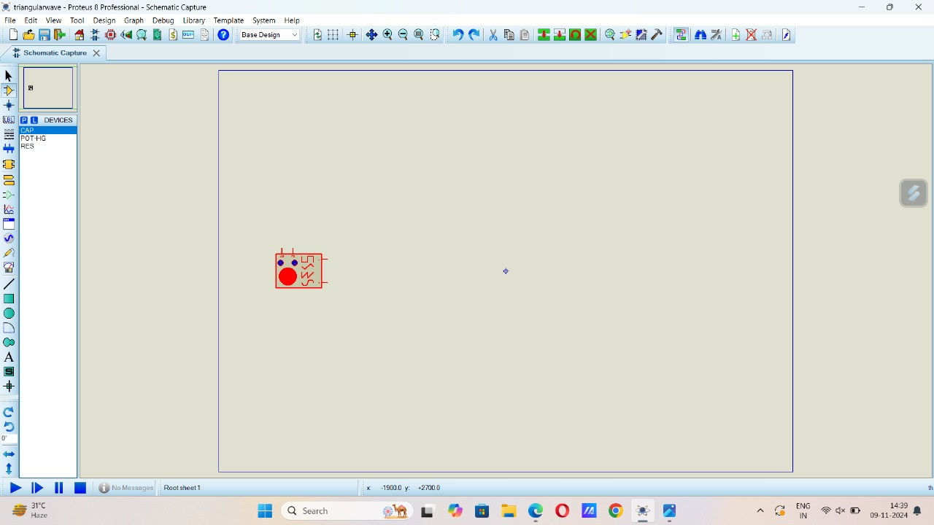
2.Connect 2 resistors R1 and R2 and change the resistance to 10k for both.
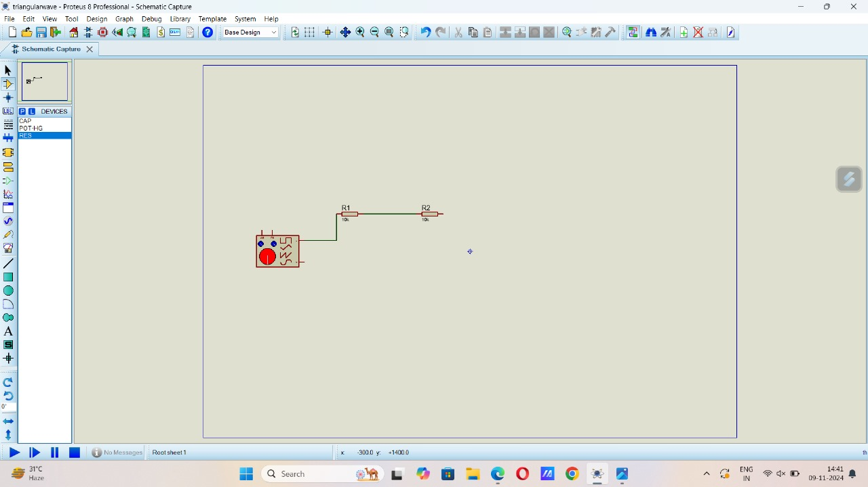

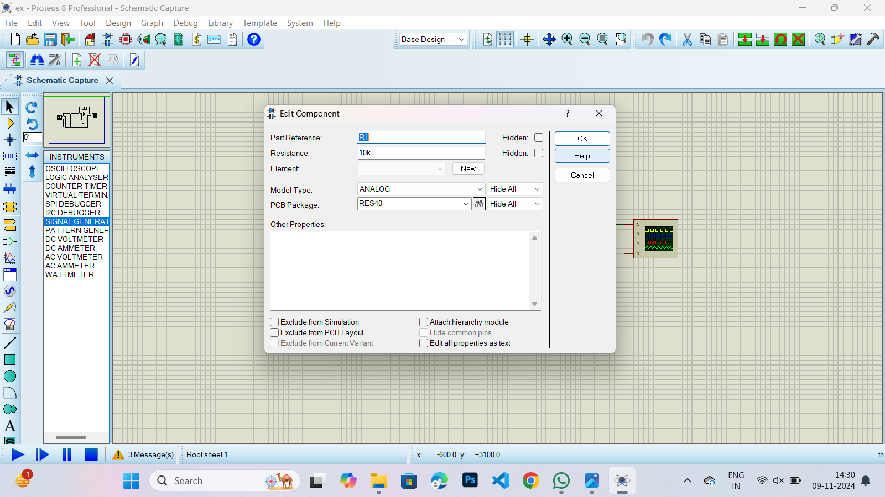

3.Add capacitor C1 with 10nf between the resistors and connect it to the ground.
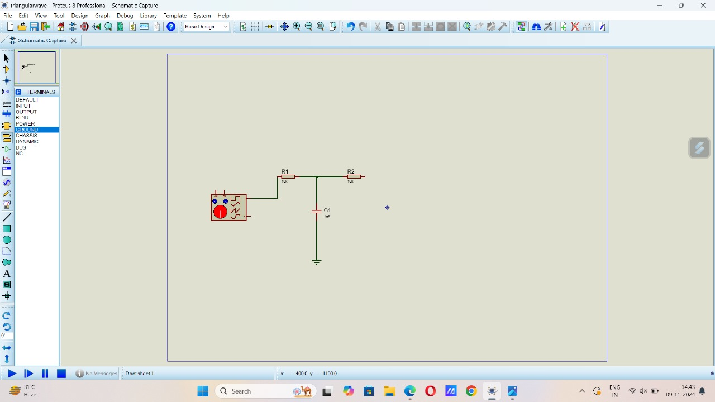

4.Add POT-HG to the from R2.
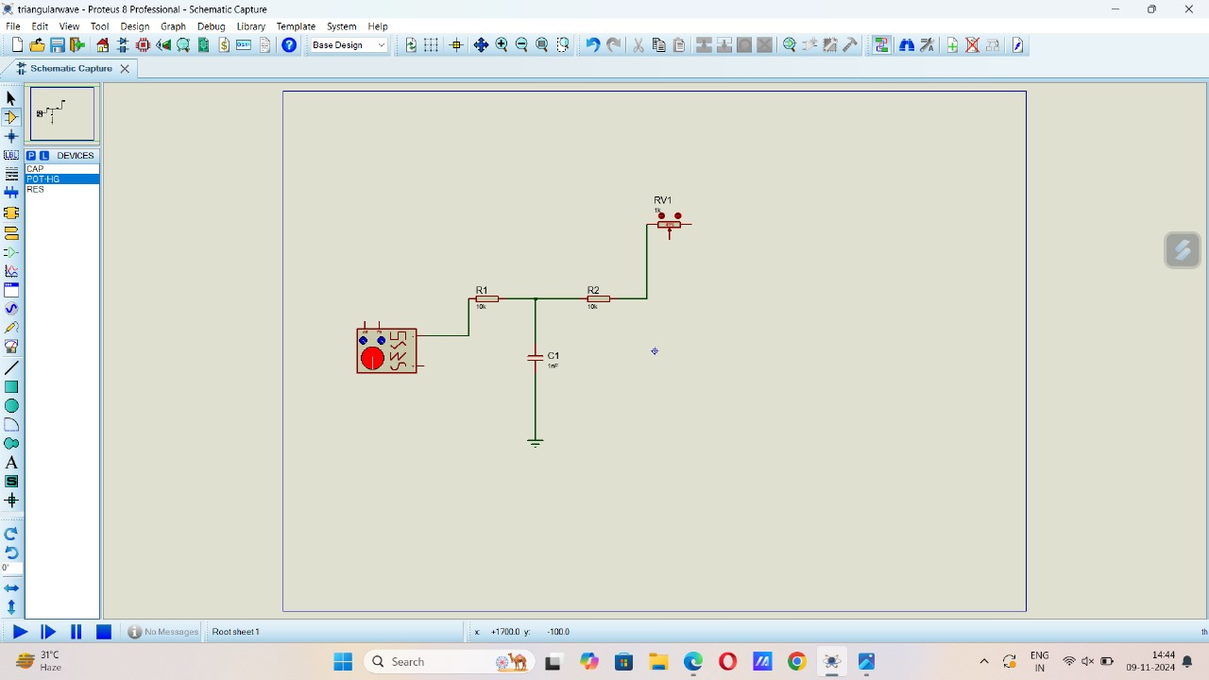

5.Add 741 from R2 and connect to 2 of 741, and connect 3 to the ground.
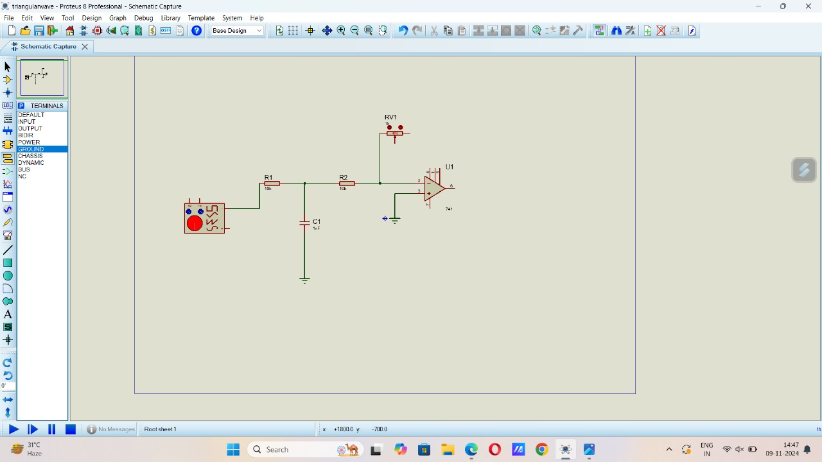

6.Add DC to 7 and 4 of 741.
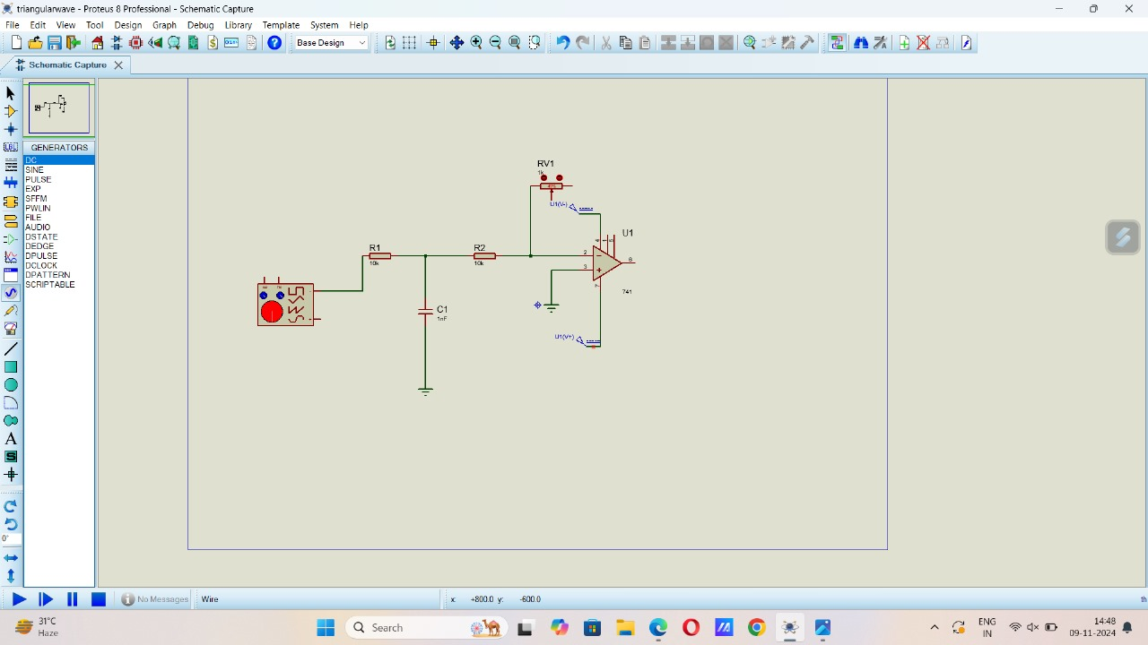
7.connect Oscilloscope as shown in the figure.
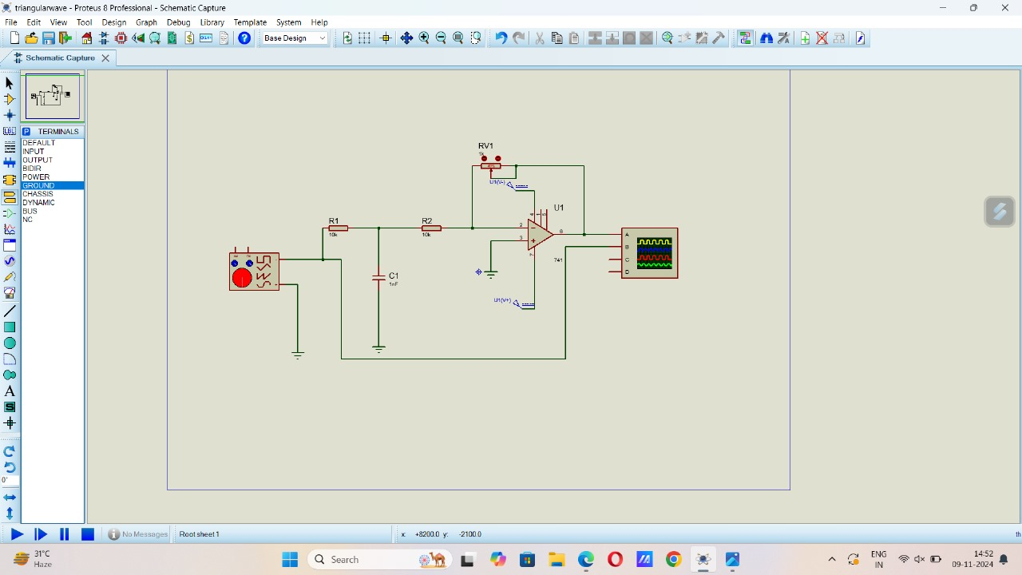

Output:
-Adjust the frequency accordingly to get the triangular wave.
